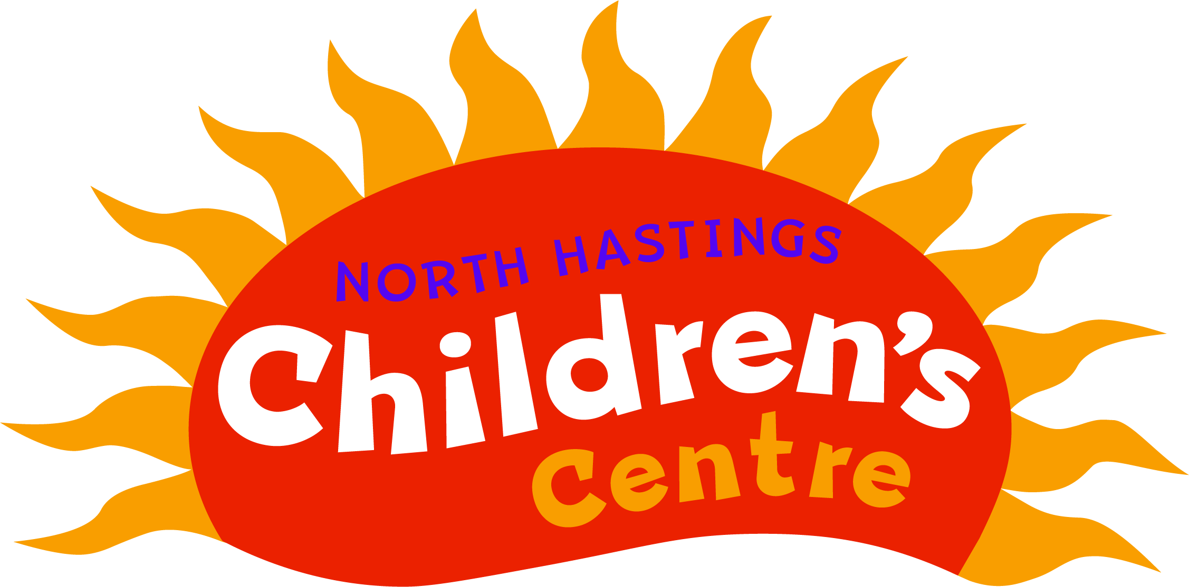
North Hastings Children’s Services
20 Hastings Heritage Way, Box 1232
Bancroft, ON K0L 1C0

SLEEP LOG
PARENT’S INSTRUCTIONS: EXAMPLES: SPECIFIC STUFFIE, BLANKET, ETC.

CHILD’S NAME | DATE | PARENTS PREFERENCES | PARENT’S SIGNATURE

